RESOURCE PACK OF INFORMATION FOR AUTHORS

The article text is carried out in Microsoft Word format (*.docx) in Ukrainian or English using the template and styles provided in the sampler:
UDC – UDC style
Title of article – TITLE style
Surname, name of the author (authors) – Name Affilation style
Affilation of the author (authors): Organization, department, scientific degree – Title style

Abstract – Abstract Text style
Keywords – Keywords style
The title of the article sections – Heading SECTION style
The main body of the article headings and sections – Journal 2 style
Table names – Table style
Figures, charts – Picture style
Title of Literature section – References title style
Line space – 1,0.

All the objects, connected with the text, (tables, graphs, drawings, formulas, prepared in the Equation Editor, etc.) should be strictly located in the next paragraph.

Mathematical formulas are carried out in the built-in MathType editor of Microsoft Word under standard settings. Only the formulas which have the references in the text should be numbered. Numbering of the formulas is continuous: (1), (2), .... The explanation should be given to the formulas, which begins with the words "where ....". The interval before and after the formula is 6pt.
Short formulas, where it is possible, should be in the line of text using "/" (forward-slash) instead of a horizontal line; instead of the exponent – Exp(x); inferior signs should be used for formatting.

Note! Cyrillic notation in the explanation to the formulas must be formatted in the regular type (Regular), Latin one is italics (Italic), the subscripts (inferior signs) always have a regular type (Regular).
The indentation from the margin to the formula and from the formula to the formula number are made using the tab character (TAB key).
For example,

, (1)

where σ(h) is the thickness stress h; b is sample thickness; x is the coordinate.
The combination of the ordinary type (Times New Roman) and the symbol type (Symbol) should be used in the designations.

Graphs for the article are plotted using Microsoft Word, Microsoft Graph, Grapher, etc. Numerical data for the curves must be added as separate files ( *.xlsx або *.txt).
All the axis should have scale and names.

Graphic files (*.jpg) must be given in a separate file with at least 600 dpi resolving capacity. If there are the captions in the drawings, they should be added as a separate file Microsoft Word (*.docx).
The drawings in Microsoft Word are allowed only as an associated object. All the literal or numeric designations have usually to be explained in the main text near the illustration. The figure caption begins with the word "Fig." and the consecutive number, then the Name. Center drawing in page. When mentioning this drawing in the text you should use the abbreviation "Fig.1".
For example, the diagram for determining the height of gravity center fall is shown in Fig.1.
The drawing and its name are interspersed into the table, and then the table borders are hidden.

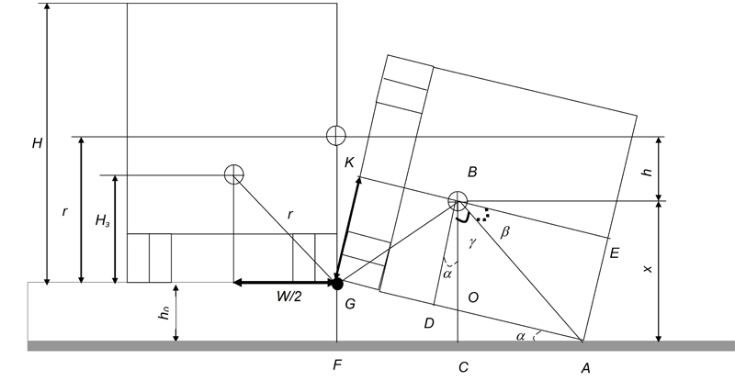
Fig. 1 Diagram for determining the height of gravity center fall

Fig. 1 Diagram for determining the height of gravity center fall

Tables are part of the text and should not be graphic objects. Use short headings in the tables, indicate the measurement units. The presence of blank columns in the table is prohibited.
Creating a table, follow this example:

Table 1
Comparison of the proposed solution with the obtained Bubnov solution
1 | Число n проміжних опор | 3 | 4 | 5 | 6 | 7 | 8 | 9 | 10 | 11
2 | Ф-ла (13) | 10,24 | 14,47 | 18,66 | 22,81 | 26,93 | 31,04 | 35,12 | 39,19 | 43,25
3 | Ф-ла (12) | 10 | 14 | 18 | 22 | 26 | 30 | 34 | 38 | 42
4 |  | 2,37 | 3,26 | 3,54 | 3,56 | 3,47 | 3,34 | 3,19 | 3,04 | 2,89

AUTO-NAMERING OF THE LIST IS PROHIBITED.
Source references in the text of the article have the form [1] , [3-5]. In the list the literary sources are given in the order in which they are mentioned in the text of the article (not in alphabetical order). All the literary sources should necessarily be referenced in the text. Sources are formatted in accordance with AUSS 8302: 2015.
In the list of source references, please indicate the DOI. At the same time, the list should contain at least 10 sources, 5 of which were published not earlier than 2000.
References in Roman alphabet (References) must be made according to the international bibliographic standard APA 6 version.
Author's Data (in the original language of the article) must contain ORCID, e-mail, address of the organization, Academic status and Scientific degree.

Шваб’юк Василь Іванович
Луцький національний технічний університет, д.т.н., професор
вул. Потебні, 56 Луцьк, Україна 43017
v.shvabyuk@gmail.com,
ORCID: 0000-0019-1800-5115
Рачинська Алла Леонідівна
Одеський національний університет ім. І.І. Мечнікова, к.ф.-м.н., доцент
Вул. Дворянська, 2 Одеса, Україна 65082
rachinskaya@onu.edu.ua,
ORCID: 0000-0003-2430-9603
Мальцева Євгенія Олександрівна
Одеський національний економічний університет
Вул. Преображенська, 8 Одеса, Україна 65082
mmmd@oneu.edu.ua
ORCID: 0000-0002-8769-023X

Vasyl Svabyuk

Lutsk National Technical University, Doctor of Technical Science, Professor
56 Potebni Street, Lutsk, Ukraine, 43017
v.shvabyuk@gmail.com,
ORCID: 0000-0019-1800-5115
Alla Rachinskaya
Odesa I. I. Mechnikov National University, Ph.D., Associate Professor
2 Dvoryanska Street, Odesa, Ukraine, 65082
rachinskaya@onu.edu.ua,
ORCID: 0000-0003-2430-9603
Maltseva Evgenia
Odesa National Economic University
8 Preobrazhenskaya Street, Odessa, Ukraine, 65082
mmmd@oneu.edu.ua
ORCID: 0000-0002-8769-023X

The editorial board invites authors to download the article template:
Template .docx

